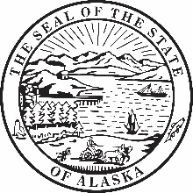 | STATE OF ALASKA  Social Security Number Verification Authorization

This form is only provided for those employees who are unable to apply for a copy of their social security card directly with the Social Security Administration. (Employees not located in the Greater Anchorage area, Juneau, and Fairbanks).

Full Name: First Name MI Last Name
Date of Birth: MM/DD/YYYY
Social Security Number: XXX-XX-XXXX
Address: Address
City: City State: AK Zip: Zip Code

I authorize the Division of Personnel and Labor Relations, Department of Administration to contact the Social Security Administration to verify my Social Security Number and name for purposes of employment to the following:

PCN: PCN
Position Title: Position Title
Department: Choose Department
Division: Division

I am the individual, to whom the requested information or record applies, or the parent or legal guardian of a minor, or the legal guardian of a legally incompetent adult. I declare under penalty of perjury (28 CFR § 16.41(d)(2004)) that I have examined all the information on this form, and any accompanying statements or forms, and it is true and correct to the best of my knowledge. I understand that anyone who knowingly or willfully seeks or obtain access to records about another person under false pretenses is punishable by a fine of up to $5,000. I also understand that I must pay all applicable fees for requesting information for a non-program-related purpose.

Signature Date

