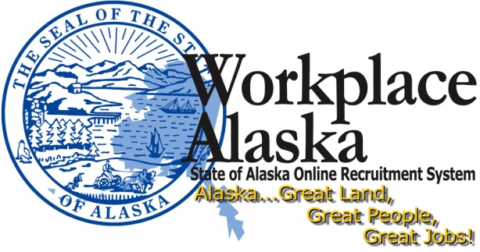 | DVR Provisional Hire:  Hiring Manager  Request for  Hire Approval  Checklist

Department / Division: |  | Position Control Number (PCN):
Job Class: |  | Hiring Manager:
Selected DVR Client: |  | Date Submitted to Agency HR:

COMMENTS (including Hire Location)

Please send this checklist as an e-mail attachment to recruitment staff in your Agency HR Office to obtain approval for your Provisional Hire. If you have not completed this form, your request will be returned. Answer all questions.
**You may not offer the position until approved by Agency HR**

All Positions:
I certify I have received departmental approval to recruit for this vacant position.  ** Your certification also includes the Departmental Administrative Services Director, or equivalent, is an agreement that the PD accurately reflects the current duties **  ** DOPLR does not need the approval information. It is the Hiring Manager’s responsibility to ensure departmental procedures are followed. ** | Yes: | No:

At the beginning of the Provisional Hire recruitment and selection process, did you check with recruitment staff in your Agency HR Office to ensure there were no available employees with preferential rights to the position? | Yes: | No:

Did you ensure the DVR client(s) met the minimum qualifications (MQs) for the job class? | Yes: | No:
If a DVR client is using education to meet the minimum qualifications he/she must provide transcripts prior to or at the time of interview. | Understand:

I have read and will follow the guidance in the State of Alaska Provisional Hire Program (pdf) document found on the Hiring Managers Resources page on the Division of Personnel and Labor Relations website. | Yes: | No:

If the DVR client disclosed a felony conviction at any time, or a misdemeanor conviction in the last five (5) years, did you verify with recruitment staff there is no direct nexus between the nature of offense and the work of the position? | Yes: | No: | N/A:

Did you have all interviewed DVR clients sign the Pre-Employment Certification form prior to or at the time of interview?  You must have the Pre-Employment Certification form signed prior to contacting references and requesting hire approval. | Yes: | No:

Firearm/Ammunition Positions:
If this position requires the use or possession of firearms or ammunition, the DVR client must sign the Firearm Certification Form. If required, did you verify that the DVR client does not have any domestic violence convictions?  Contact recruitment staff in your Agency HR Office if an applicant indicates a domestic violence conviction and if there are any questions. | Yes: | No: | N/A:

Commercial Driver's License (CDL) Required positions:
Have you submitted a copy of the DVR client’s CDL with endorsements to Agency HR?  All new hires or employees transferring into a CDL position must take and pass a drug test BEFORE appointment. Selected DVR candidate cannot start work in a CDL position until Agency HR or designee has scheduled and received confirmation of proposed appointee passing the required drug test.  Agency HR may assist you with this process. | Yes: | No: | N/A:

All Positions - Job Offer:
Checking references is a policy (AAM 100.120) of the State of Alaska. Did you check at least two references for the selected DVR client?  If the DVR client is a current or former state employee, you should request relevant employment records from Employee Records. Your request can be e-mailed to:  doa.dop.employeerecords@alaska.gov  (Remember to attach your Pre-employment Certification to your request)  Call Employee Records at 465-3380 for assistance. | Yes: | No:

Nepotism:
State policy prohibits employees from being in an employment relationship with an immediate family member, including a conjugal relationship that is not a legal marriage or with an individual who is related within and including the second degree of kindred.  Applicant(s) selected for interview will be required to disclose at time of interview if he/she has an immediate family member or are related within and including the second degree of kindred to an individual employed in the department in which they are seeking employment. This information will be disclosed on the Pre-Employment Certification form.  If the proposed DVR Client is related (as noted above) to anyone employed currently working in the department, is a nepotism waiver completed?  **If so, you must have a nepotism waiver approved through your department Commissioner’s Office prior to making the job offer**. | Yes: | No: | N/A:

Other:
Have you submitted the following documentation to Agency HR Office for hire approval?  - Severe Disability (SD) certification letter signed by DVR Director  - Workplace Alaska Applicant Profile  - Pre-Employment Certification form  - Firearm Certification form (if applicable)  - Educational Transcripts (if applicable)  - Approved Nepotism Waiver (if applicable)  - Any other relevant information. | Yes: | No:

I understand that I must retain all documentation regarding this selection for two (2) years, in accordance with 2 AAC 07.113. | Understood:

I understand that this is a 4-month provisional appointment. After 4 months of satisfactory work I must complete a state performance evaluation to convert the DVR client from provisional to probationary. I also understand if I continue to employ the DVR client the four (4) months of provisional hire period will count towards the probationary period. | Understood:

All Hiring Managers must notify his/her entire applicant pool regarding the outcome of the recruitment. If you considered a pool of DVR clients you may either contact them via telephone or in writing.  I certify as a Hiring Manager, I will notify my entire applicant pool regarding the recruitment outcome. | Yes: | No:

This recruitment and selection process is in accordance with any applicable departmental policies and procedures. This recruitment is also in accordance with Department of Administration, Division of Personnel & Labor Relations recruitment guidelines, policies, procedures, collective bargaining contract(s), and State and Federal employment laws. I also understand that if I deliberately provide false information during this process, I may be liable and lose my rights as a hiring manager. I certify that the above information is true and complete. Yes: No:
Save this checklist as "PHHireApprovalChecklist PCN__-____" and email this file to your Agency HR Office.
COMMENTS (Please explain below any “No” answers”)

IF YOU HAVE ANY QUESTIONS REGARDING THESE PROCEDURES OR ANY PART OF THE RECRUITMENT AND SELECTION PROCESS, PLEASE CONTACT AGENCY HR.

